26 — Загрузка и отображение фотографий из интернета от 10.10.26 9ИС-360 Чайкин А.

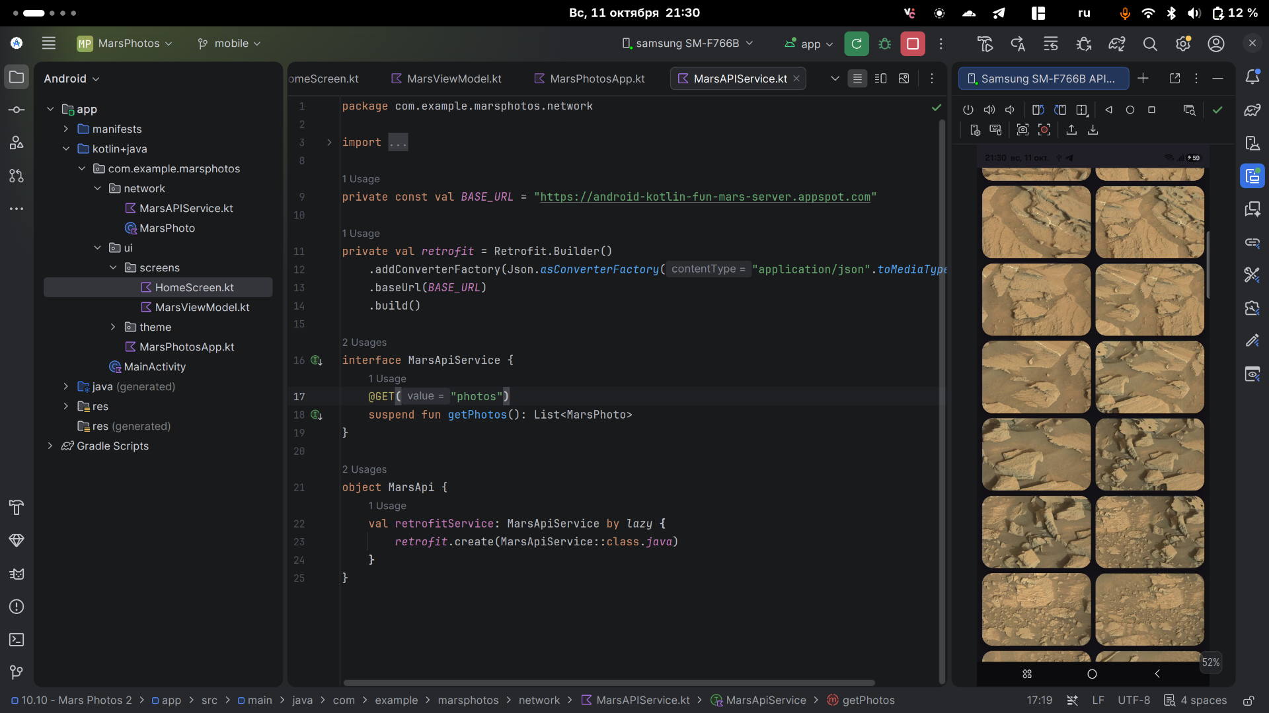
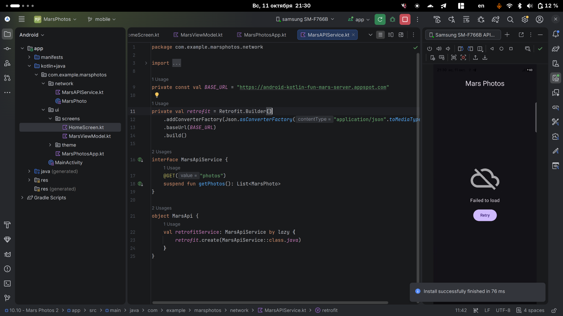

MarsViewModel.kt

package com.example.marsphotos.ui.screens
import androidx.compose.runtime.getValue
import androidx.compose.runtime.mutableStateOf
import androidx.compose.runtime.setValue
import androidx.lifecycle.ViewModel
import androidx.lifecycle.viewModelScope
import com.example.marsphotos.network.MarsApi
import kotlinx.coroutines.launch
import java.io.IOException
import com.example.marsphotos.network.MarsPhoto
import retrofit2.HttpException
sealed interface MarsUiState {
data class Success(val photos: List<MarsPhoto>) : MarsUiState
object Error : MarsUiState
object Loading : MarsUiState
}
class MarsViewModel : ViewModel() {
var marsUiState: MarsUiState by mutableStateOf(MarsUiState.Loading)
private set
init {
getMarsPhotos()
}
fun getMarsPhotos() {
viewModelScope.launch {
marsUiState = try {
val result = MarsApi.retrofitService.getPhotos()
MarsUiState.Success(result)
} catch (_: IOException) {
MarsUiState.Error
}
}
}
}

HomeScreen.kt

package com.example.marsphotos.ui.screens
import androidx.compose.foundation.Image
import androidx.compose.foundation.layout.Arrangement
import androidx.compose.foundation.layout.Box
import androidx.compose.foundation.layout.Column
import androidx.compose.foundation.layout.PaddingValues
import androidx.compose.foundation.layout.aspectRatio
import androidx.compose.foundation.layout.fillMaxSize
import androidx.compose.foundation.layout.fillMaxWidth
import androidx.compose.foundation.layout.padding
import androidx.compose.foundation.layout.size
import androidx.compose.foundation.lazy.grid.GridCells
import androidx.compose.foundation.lazy.grid.LazyVerticalGrid
import androidx.compose.foundation.lazy.grid.items
import androidx.compose.material3.Button
import androidx.compose.material3.Card
import androidx.compose.material3.CardDefaults
import androidx.compose.material3.Text
import androidx.compose.runtime.Composable
import androidx.compose.ui.Alignment
import androidx.compose.ui.Modifier
import androidx.compose.ui.layout.ContentScale
import androidx.compose.ui.platform.LocalContext
import androidx.compose.ui.res.painterResource
import androidx.compose.ui.res.stringResource
import androidx.compose.ui.tooling.preview.Preview
import androidx.compose.ui.unit.dp
import coil.compose.AsyncImage
import coil.request.ImageRequest
import com.example.marsphotos.R
import com.example.marsphotos.network.MarsPhoto
import com.example.marsphotos.ui.theme.MarsPhotosTheme
@Composable
fun HomeScreen(
marsUiState: MarsUiState,
retryAction: () -> Unit,
modifier: Modifier = Modifier
) {
when (marsUiState) {
is MarsUiState.Loading -> LoadingScreen(modifier = modifier.fillMaxSize())
is MarsUiState.Success -> PhotosGridScreen(marsUiState.photos, modifier)
is MarsUiState.Error -> ErrorScreen(retryAction, modifier = modifier.fillMaxSize())
}
}
@Composable
fun LoadingScreen(modifier: Modifier = Modifier) {
Image(
modifier = modifier.size(200.dp),
painter = painterResource(R.drawable.loading_img),
contentDescription = stringResource(R.string.loading)
)
}
@Composable
fun ErrorScreen(retryAction: () -> Unit, modifier: Modifier = Modifier) {
Column(
modifier = modifier,
verticalArrangement = Arrangement.Center,
horizontalAlignment = Alignment.CenterHorizontally
) {
Image(
painter = painterResource(id = R.drawable.ic_connection_error),
contentDescription = ""
)
Text(
text = stringResource(R.string.loading_failed),
modifier = Modifier.padding(16.dp)
)
Button(onClick = retryAction) {
Text(stringResource(R.string.retry))
}
}
}
@Composable
fun ResultScreen(photos: String, modifier: Modifier = Modifier) {
Box(modifier = modifier, contentAlignment = Alignment.Center) {
Text(text = photos)
}
}
@Composable
fun MarsPhotoCard(photo: MarsPhoto, modifier: Modifier = Modifier) {
Card(
modifier = modifier,
elevation = CardDefaults.cardElevation(defaultElevation = 8.dp)
) {
AsyncImage(
model = ImageRequest.Builder(context = LocalContext.current)
.data(photo.imgSrc)
.crossfade(true)
.build(),
error = painterResource(R.drawable.ic_broken_image),
placeholder = painterResource(R.drawable.loading_img),
contentDescription = stringResource(R.string.mars_photo),
contentScale = ContentScale.Crop,
modifier = Modifier.fillMaxWidth()
)
}
}
@Composable
fun PhotosGridScreen(
photos: List<MarsPhoto>,
modifier: Modifier = Modifier,
contentPadding: PaddingValues = PaddingValues(0.dp),
) {
LazyVerticalGrid(
columns = GridCells.Adaptive(150.dp),
modifier = modifier.padding(horizontal = 4.dp),
contentPadding = contentPadding,
) {
items(items = photos, key = { photo -> photo.id }) { photo ->
MarsPhotoCard(
photo = photo,
modifier = Modifier
.padding(4.dp)
.fillMaxWidth()
.aspectRatio(1.5f)
)
}
}
}

MarsAPIService.kt

package com.example.marsphotos.network
import com.jakewharton.retrofit2.converter.kotlinx.serialization.asConverterFactory
import kotlinx.serialization.json.Json
import okhttp3.MediaType.Companion.toMediaType
import retrofit2.Retrofit
import retrofit2.http.GET
private const val BASE_URL = "https://android-kotlin-fun-mars-server.appspot.com"
private val retrofit = Retrofit.Builder()
.addConverterFactory(Json.asConverterFactory("application/json".toMediaType()))
.baseUrl(BASE_URL)
.build()
interface MarsApiService {
@GET("photos")
suspend fun getPhotos(): List<MarsPhoto>
}
object MarsApi {
val retrofitService: MarsApiService by lazy {
retrofit.create(MarsApiService::class.java)
}
}

MarsPhoto.kt

package com.example.marsphotos.network
import kotlinx.serialization.SerialName
import kotlinx.serialization.Serializable
@Serializable
data class MarsPhoto(
val id: String,
@SerialName(value = "img_src") val imgSrc: String
)

